**Largest Rectangle in Histogram:-**

Given *n* non-negative integers representing the histogram's bar height where the width of each bar is 1, find the area of largest rectangle in the histogram.

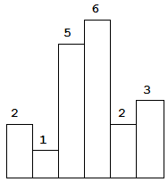  
Above is a histogram where width of each bar is 1, given height = [2,1,5,6,2,3].

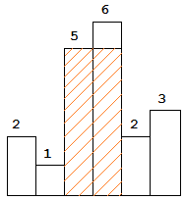  
The largest rectangle is shown in the shaded area, which has area = 10 unit.

**Example:**

**Input:** [2,1,5,6,2,3]

**Output:** 10

**Example:  
Input:   
2  
7  
6 2 5 4 5 1 6  
4  
6 3 4 2  
Output:  
12  
9**

**Explanation:  
Testcase1:  
